Subject: Reduce Expense Processing Time by 50% with Norming’s eExpense Claim Suite

Dear [Customer's Name],
Manual expense claims, travel requests, and cash advances often result in delays, errors, and overspending. Norming’s eExpense Claim Suite, fully integrated with Sage 300, solves these challenges by automating workflows, enforcing compliance, and cutting processing time in half.
Here’s how it benefits you:
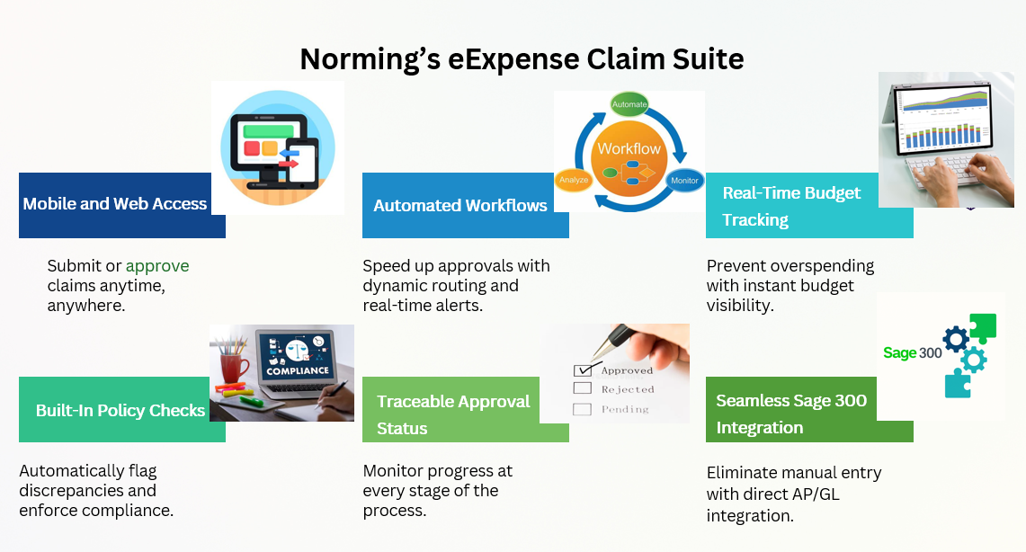

Ready to see it in action?
🎥 Watch how it works on YouTube
📎 Download the brochure to discover key features and benefits
📩 Want to learn more?
Contact your Sage 300 partner today to explore how Norming’s eExpense Claim Suite can help your team save time, control budgets, and improve accuracy!
For questions or a personalized demo, reply to this email or visit our website.
Best regards,
[Your Name]
[Your Position]
[Your Contact Information]
[Company Website]

